Subject: Pharmaceutical Chemistry 2.
Lecture 4: Medicinal substances affecting the cholinergic system.
Acetylcholine is synthesized in the cytoplasm of the endings of cholinergic neurons. It is formed from choline and acetylcoenzyme A (of mitochondrial origin) with the participation of the cytoplasmic enzyme choline acetylase (choline acetyltransferase).

Acetylcholine is deposited in synaptic vesicles (vesicles). Each of them contains several thousand molecules of acetylcholine.

Nerve impulses cause the release of acetylcholine into the synaptic cleft, after which it interacts with cholinergic receptors.
In 1921, studying the influence of the vagus nerve on the intensity of cardiac activity, Otto Loewy made the following experiment: the heart of a frog with a vagus nerve was separated and placed in a vessel with a nutrient solution that did not affect the heart rate (in it it could beat for a long time) . By stimulating the nerve, Loewy achieved cardiac arrest, after which the solution from this vessel was added to another vessel, where the heart of the same frog, but without the nerve, contracted. Cardiac activity also weakened and stopped altogether. Thus, Levi came to the conclusion that when the nerve is excited, a certain substance is released, which retains its effect even in solution. This substance turned out to be acetylcholine. Loewy received the Nobel Prize in Physiology in 1936 for his discoveries concerning the chemical transmission of nerve impulses.
Biosynthesis of acetylcholine:

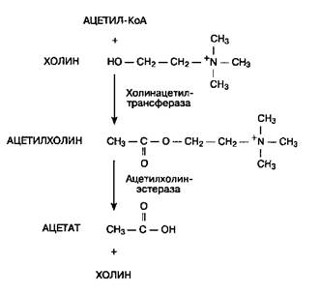
According to available data, the cholinergic receptor of neuromuscular synapses includes 5 protein subunits (α, α, β, γ, δ) surrounding the ion (sodium) channel and passing through the entire thickness of the lipid membrane. Two molecules of acetylcholine interact with two α-subunits, which leads to the opening of the ion channel and depolarization of the postsynaptic membrane.
Cholinergic receptors of different localization have unequal sensitivity to pharmacological substances. This is the basis for the selection of the so-called
• muscarinic cholinergic receptors - m-cholinergic receptors (muscarine is an alkaloid from a number of poisonous mushrooms, such as fly agaric),
• nicotine-sensitive cholinergic receptors - n-cholinergic receptors (nicotine is an alkaloid from tobacco leaves).
M-cholinergic receptors are located in the postsynaptic membrane of cells of effector organs at the endings of postganglionic cholinergic (parasympathetic) fibers. In addition, they are present on the neurons of the autonomic ganglia and in the central nervous system - in the cerebral cortex, the reticular formation). The heterogeneity of m-cholinergic receptors of different localization was established, which manifests itself in their unequal sensitivity to pharmacological substances.
The following types of m-cholinergic receptors are distinguished:
• m1-cholinergic receptors in the central nervous system and in the autonomic ganglia (however, the latter are localized outside the synapses);
• m2-cholinergic receptors - the main subtype of m-cholinergic receptors in the heart; some presynaptic m2-cholinergic receptors reduce the release of acetylcholine;
• m3-cholinergic receptors - in smooth muscles, in most exocrine glands;
The main effects of known pharmacological substances that affect m-cholinergic receptors are associated with their interaction with postsynaptic m2- and m3-cholinergic receptors. N-cholinergic receptors are located in the postsynaptic membrane of ganglionic neurons at the endings of all preganglionic fibers (in the sympathetic and parasympathetic ganglia, the adrenal medulla, the carotid sinus zone, the end plates of skeletal muscles and the central nervous system (in the neurohypophysis, Renshaw cells, etc.). Sensitivity to substances of different n Thus, the n-cholinergic receptors of the autonomic ganglia (n-cholinergic receptors of the neuronal type) differ significantly from the n-cholinergic receptors of skeletal muscles (n-cholinergic receptors of the muscle type). This explains the possibility of a selective block of ganglia (ganglion-blocking drugs) or neuromuscular transmission (curare-like drugs).
Presynaptic cholinergic and adrenoreceptors take part in the regulation of acetylcholine release in neuroeffector synapses. Their excitation inhibits the release of acetylcholine.
Interacting with n-cholinergic receptors and changing their conformation, acetylcholine increases the permeability of the postsynaptic membrane. With the excitatory effect of acetylcholine, sodium ions penetrate into the cell, which leads to depolarization of the postsynaptic membrane.
Initially, this is manifested by a local synaptic potential, which, having reached a certain value, generates an action potential. Then local excitation, limited to the synaptic region, spreads throughout the cell membrane. During stimulation of m-cholinergic receptors, G-proteins and second messengers (cyclic adenosine monophosphate - cAMP; 1,2-diacylglycerol; inositol (1,4,5) triphosphate) play an important role in signal transmission.
The action of acetylcholine is very short-lived, since it is rapidly hydrolyzed by the enzyme acetylcholinesterase (for example, in neuromuscular synapses or, as in autonomic ganglia, it diffuses from the synaptic cleft). Choline, formed during the hydrolysis of acetylcholine, is captured in a significant amount (50%) by presynaptic endings, transported to the cytoplasm, where it is again used for the biosynthesis of acetylcholine.
M-cholinergic receptors are localized in the membranes:
1) cells innervated by postganglionic parasympathetic fibers (conducting system of the heart, eyes, external secretion glands, smooth muscle cells, including bronchi and gastrointestinal tract);
2) sweat gland cells innervated by postganglionic sympathetic fibers of the cholinergic type;
3) neurons of some parts of the central nervous system (cerebral cortex, reticular formation, etc.).
N-cholinergic receptors are localized:
1) in neurons of sympathetic and parasympathetic ganglia;
2) in carotid sinus glomeruli (located at the division of the carotid arteries);
3) in chromaffin cells of the adrenal medulla;
4) in skeletal muscle cells;
5) in the neurons of some parts of the CNS. Chemical (including pharmacological) substances can affect various processes related to synaptic transmission:
• synthesis of acetylcholine;
• mediator release (for example, carbacholine enhances the release of acetylcholine at the level of presynaptic endings, as well as botulinum toxin, which prevents the release of the mediator);
• interaction of acetylcholine with cholinergic receptors;
• enzymatic hydrolysis of acetylcholine;
• the capture of presynaptic endings of choline, which is formed during the hydrolysis of acetylcholine (for example, hemicholinium, which inhibits neuronal capture - the transport of choline through the presynaptic membrane).
Anticholinergic drugs are used to treat extrapyramidal disorders (including those caused by neuroleptics). Also, some of them are used in Parkinson's disease, Little's disease, spastic paralysis, pyramidal paresis, in a number of diseases associated with an increase in skeletal muscle tone, in gastric and duodenal ulcers, and in bronchial asthma.
In addition, they are used in overactive bladder, although their effectiveness in this disorder is highly questionable, as shown by a Cochrane review. The difference between the effect of these drugs and the effect of placebo in clinical trials is not significant and may be due to significant side effects that interfere with blinding and may lead to a bias in the assessment in favor of the drug compared to placebo. One of the anticholinergic drugs, trospium chloride, is also known to exacerbate urinary problems.
Medicinal substances that act like acetylcholine are called cholinomimetics (from the Greek mimeticos - imitating) and are divided into:
1) M- and N-cholinomimetics (exciting both M- and N-cholinergic receptors);
2) M-cholinomimetics (exciting M-cholinergic receptors);
3) N-cholinomimetics (stimulating N-cholinergic receptors);
Drugs that block cholinergic receptors - anticholinergics, or anticholinergics (from the Greek lyticos - destructive) include:
1) M- and N-anticholinergics - blocking M- and N-cholinergic receptors;
2) M-cholinolytics - blocking M-cholinergic receptors;
3) N-anticholinergics - blocking N-cholinergic receptors.
Most cholinergics have chemical structure features in common with acetylcholine - that is why they bind to the cholinergic receptor. They are bases, ethers and contain tertiary or quaternary nitrogen atoms. Tertiary nitrogen compounds do not dissociate, are well soluble in fats. are easily absorbed in the gastrointestinal tract, penetrate the blood-brain barrier and therefore may have an effect on the central nervous system. Quaternary nitrogen-containing compounds have tetravalent nitrogen, in which three valences are firmly bonded, and the fourth can form an ionic bond with anions, for example, acids. These compounds are poorly soluble in fats, are practically not absorbed in the digestive tract, do not pass the blood-brain barrier, and therefore do not affect the brain and spinal cord. They are characterized mainly by peripheral effects.
Means affecting m- and n-cholinergic receptors
M, n-cholinomimetics
Acetylcholine
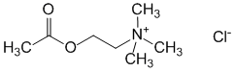
2-(Acetyloxy)-N,N,N-trimethylethanamine chloride
Synthesis of acetylcholine:
Binding of acetylcholine to muscarinic receptors:

Rules to be applied for structure-activity relationships;
-Ammonium group
Poor activity (when replacing the amino group)
-Ester group (The size of the functional ester group should not be increased because it is located in a very small hydrophobic region of the receptor.

Poor activity (when increasing or decreasing)
-Ethylene chain (there must be 2 carbon atoms in the bridge connecting the two ends, and this chain should neither lengthen nor shorten).
Bad Activity
The ammonium ion must contain at least 2 methyl groups.
Bad activity Good activity

The space between acetylcholine and the binding site is very narrow.
• Methyl groups are well suited for small hydrophobic pockets.
• ether; It interacts with the receptor through H-bonds.
• Quaternary ammonium interacts with the receptor through an ionic bond.

Acetylcholine is used during surgery on the anterior chamber of the eye (cataract removal, keratoplasty, iridoectomy) - to ensure miosis within a few seconds after the lens is released; spasm of the retinal arteries; rarely - endarteritis, intermittent claudication, trophic disorders in the stumps, atony of the intestines and bladder, radiodiagnosis of esophageal achalasia.
Carbacholin (Carbachol)
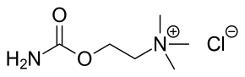
2-[(Aminocarbonyl)oxy]-N,N,N-trimethylethanamine chloride
Synthesis of carbachol:
Carbachol is mainly used in the treatment of glaucoma. Carbachol eye drops are used to reduce pressure in the eye in people with glaucoma. In ophthalmic surgery, it is used to constrict pupils during cataract surgery.
Topical injection into the eye is used to lower intraocular pressure in people with primary open-angle glaucoma. Intraocular injection is used to produce miosis after lens implantation during cataract surgery.
Carbachol can also be used to stimulate bladder emptying if the normal emptying mechanism is not working properly.
Methacholine
Methacholine is primarily used to diagnose bronchial hyperreactivity, which is a hallmark of asthma, and also occurs in chronic obstructive pulmonary disease. This is achieved using a bronchial or methacholine challenge test, in which the subject inhales aerosolized methacholine, resulting in bronchoconstriction. Other therapeutic applications are limited to its adverse cardiovascular effects, such as bradycardia and hypotension, which arise from its function as a cholinomimetic.

Cevimeline
Cevimeline (trade name Evoxac) is a synthetic analogue of the natural alkaloid muscarine with a specific agonistic effect on the M1 and M3 receptors. It is used in the treatment of dry mouth and Sjögren's syndrome.
M,n-anticholinergics
Trihexyphenidyl (Cyclodol)
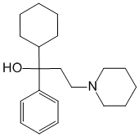
alpha-Cyclohexyl-alpha-phenyl-1-piperidine propanol
It has a pronounced central n-anticholinergic, as well as peripheral m-anticholinergic action. The central action helps to reduce or eliminate movement disorders associated with extrapyramidal disorders. In parkinsonism, it reduces tremor, to a lesser extent affects rigidity and bradykinesia. In connection with the peripheral anticholinergic action reduces salivation, to a lesser extent - sweating and greasiness of the skin.
Parkinsonism (idiopathic, atherosclerotic, postencephalitic, medicinal), Little's disease, spastic paralysis associated with damage to the extrapyramidal and pyramidal (less often) systems.

Anticholinesterase agents
Physostigmine salicylate
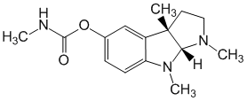
3aS-cis)-1,2,3,3a,8,8a-Hexahydro-1,3a,8-trimethylpyrrolo[2,3-b]indol-5-ol methylcarbamate
Synonyms: Ezerina salicylate, Eserini salicylas, Physostigmine salicylate, Physostigminum salicylicum.
Physostigmine (also known as eserine, from éséré, the West African name for Calabar beans) is a parasympathomimetic alkaloid, a reversible cholinesterase inhibitor. It is the main alkaloid of the so-called Calabar beans - the seeds of the West African plant Physostigma venenosum - poisonous physostigma. In medical practice, it is mainly used for glaucoma, as a means of constricting the pupil and reducing intraocular pressure [1].
It is used for angle-closure glaucoma (acute attack), diagnostics in ophthalmology, intestinal and bladder atony, neuromuscular diseases.
Neostigmine (prozerin)

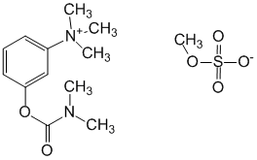
3-[[(Dimethylamino)carbonyl]oxy]-N,N,N-trimethylbenzolaminium methyl sulfate
Neostigmine methyl sulfate (Prozerin) is a cholinesterase inhibitor. In terms of peripheral activity, it is close to physostigmine and galantamine, it does not have a central effect, since it does not penetrate well through the blood-brain barrier.
It binds to the anionic and esterase centers of the acetylcholinesterase molecule, reversibly screens them from acetylcholine, as a result of which its enzymatic hydrolysis stops, acetylcholine accumulates and cholinergic transmission increases. Narrows the pupils, reduces intraocular pressure, causes spasm of accommodation, bradycardia, increased tone and contractility of the smooth muscles of the bronchi (to bronchospasm), gastrointestinal tract and bladder (uterotonic effect), increased secretion of bronchial, digestive, including salivary, sweat and other exocrine glands; facilitates neuromuscular transmission, but in large doses it can inhibit it (permanent depolarization of the postsynaptic membrane of the skeletal, including respiratory, muscles develops). In therapeutic doses, it does not have a central effect, because. it is difficult to penetrate the BBB (in toxic doses it depresses the central nervous system). It has a direct cholinomimetic effect on cholinergic receptors of skeletal muscles, autonomic ganglia and CNS neurons.
Application: Myasthenia gravis, movement disorders after brain injury, paralysis, recovery period after meningitis, poliomyelitis, encephalitis, weakness of labor activity (rarely), open-angle glaucoma, optic nerve atrophy, neuritis; atony of the gastrointestinal tract, atony of the bladder. Elimination of residual disorders of neuromuscular transmission with non-depolarizing muscle relaxants.

Galantamine hydrobromide
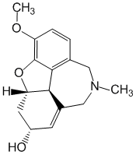
(4aS,6R,8aS)-4a,5,9,10,11,12-Hexahydro-3-methoxy-11-methyl-6H-benzofuro[3a,3,2-ef][2]benzazepin-6-ol
Hydrobromide of an alkaloid isolated from tubers of Voronov's snowdrop (Galanthus Woronowii A. Los.), Amaryllis family (Amaryllidaceae). It is also found in other snowdrop species of the genus Galanthus. White fine-crystalline powder of bitter taste. It is difficult to dissolve in water, practically insoluble in ethyl alcohol. Reversibly inhibits acetylcholinesterase, enhances and prolongs the action of endogenous acetylcholine. Facilitates the conduction of impulses in cholinergic, incl. neuromuscular, synapses, enhances excitation processes in the reflex zones of the spinal cord and brain. Increases the tone of smooth and skeletal muscles, stimulates the secretion of the digestive and sweat glands. Causes miosis and spasm of accommodation, lowers intraocular pressure in angle-closure glaucoma. When injected into the conjunctival sac, it may cause temporary swelling of the conjunctiva. Penetrates through the BBB, enhances the processes of excitation in the central nervous system. When used in the complex therapy of spastic forms of cerebral palsy, it improves neuromuscular conduction, increases muscle contractility, and has a positive effect on mnestic functions. By increasing the activity of the cholinergic system, cognitive function may improve in patients with dementia of the Alzheimer's type.
Armin
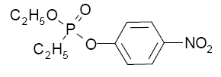
Armine belongs to the group of organic esters of phosphoric acid (organophosphorus compounds - FOS).
The drugs of this group have strong anticholinesterase activity and are irreversible cholinesterase inhibitors.
The effects caused by these substances basically coincide with the effects of other anticholinesterase drugs (Physostigmine, Prozerin, etc.), but they act much stronger and longer. In appropriate doses (or concentrations), these substances exhibit a strong toxic effect associated with hyperactivation of the central and peripheral cholinergic systems of the body. Some substances of this group, in connection with the strong miotic effect they cause, have found application (in low concentrations) as local miotic and antiglaucoma drugs.
Armin is the main antiglaucoma drug in this group. Previously produced drugs phosphatol, chlorophthalmos, pyrophos, chlorophosphol are excluded from the nomenclature of medicines.
Armin is used as a miotic and antiglaucoma agent in the form of eye drops at a concentration of 0.01% (1:10000). Assign 1-2 drops 2-3 times a day. Armin can be used simultaneously with other antiglaucoma drugs.

Means affecting m-cholinergic receptors
M-cholinomimetics (muscarinomimetics)
Pilocarpine hydrochloride
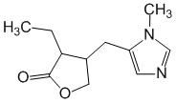
(3S-cis)-3-Ethyldihydro-4-[(1-methyl-1H-imidazol-5-yl)methyl]-2(3H)-furanone
Pilocarpine is isolated from the leaves of plants of the genus Pilocarpus, in which its content reaches 0.8% (based on dry matter).
Pilocarpine excites peripheral M cholinergic receptors, which cause increased secretion of the digestive and bronchial glands, a sharp increase in sweating, pupil constriction with a simultaneous decrease in intraocular pressure, and an increase in smooth muscle tone. It is used for glaucoma and other eye diseases.
An alkaloid extracted from the plant Pilocarpus pennatifolius, native to Brazil. In medical practice, pilocarpine hydrochloride (Pilocarpini hydrochloridum) is used.
Synthesis of pilocarpine:
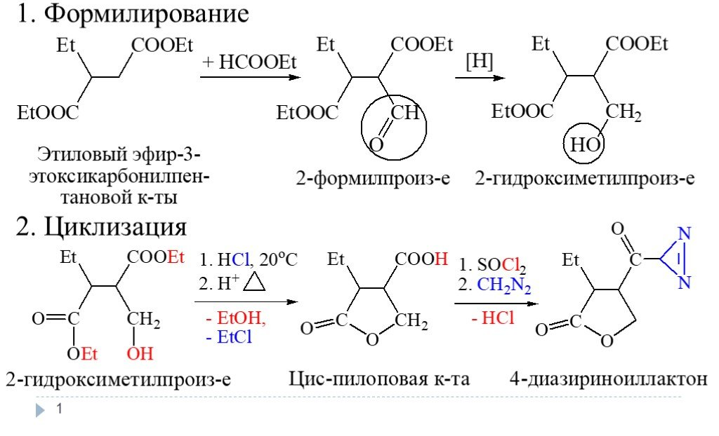
Pilocarpine excites peripheral m-cholinergic receptors, causes an increase in the secretion of the digestive and bronchial glands, a sharp increase in sweating, pupil constriction (with a simultaneous decrease in intraocular pressure and improvement in the trophism of eye tissues), an increase in the tone of smooth muscles, bronchi, intestines, gall and bladder, uterus. Pilocarpine antagonists are atropine and other m-anticholinergics.
Metabolism of pilocarpine:
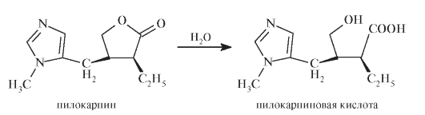
When taken orally, pilocarpine is rapidly absorbed, but it is usually not given orally. When instilled into the conjunctival sac of the eye, it is poorly absorbed in normal concentrations and does not have a pronounced systemic effect.
Pilocarpine is widely used in ophthalmic practice to lower intraocular pressure in glaucoma, as well as to improve eye trophism in case of thrombosis of the central retinal vein, acute obstruction of the retinal artery, optic nerve atrophy, and vitreous hemorrhages. Pilocarpine is also used to stop the mydriatic action after the use of atropine, homatropine, scopolamine or other anticholinergic substances to dilate the pupil in ophthalmological studies.
Assign pilocarpine in the form of aqueous solutions; solutions with the addition of polymeric compounds (methylcellulose, etc.), which have a prolonged effect; ointments and special films made of polymeric material containing pilocarpine. Usually used 1% or 2% aqueous solution of pilocarpine 2-3-4 times a day. In rare cases, more concentrated solutions (5-6%) are prescribed.
Pilocarpine is often used in combination with other drugs that reduce intraocular pressure: β-blockers (see Timolol), adrenomimetics, etc.
Before going to bed, you can put 1-2% pilocarpine ointment behind your eyelids.
It is advisable to prescribe eye films with pilocarpine in cases where more than 3-4 instillations of pilocarpine solutions per day are required to normalize the tone of the eyeball. The film is laid with eye tweezers for the lower eyelid 1-2 times a day. Wetting with lacrimal fluid, it swells and is retained in the lower conjunctival fornix. Immediately after laying the film, keep the eye in a stationary state for 30-60 seconds until the film is wetted and it passes into a soft (elastic) state.

Aceclidine
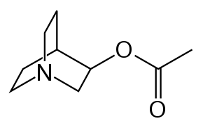
1-Azabicyclo[2.2.2]octan-3-ol acetate
Aceclidine is a drug, the original Soviet drug, M-cholinomimetic. It is a cholinomimetic substance that stimulates predominantly cholinergic systems of the body. According to the chemical structure, aceclidine belongs to the derivatives of 3-oxyquinuclidine (see also Oxylidine, Imekhin, Temekhin).
Aceclidine is as effective as morphine and has no side effects. The name of the drug was assigned by the developer - VNIHFI as a derivative of the word "3-acetoxyquinuclidine salicylate". Aceclidin is an officinal drug, which is prepared in the production departments of pharmacies according to the Collection of unified medicinal prescriptions (officinal formula).
Stimulates m-cholinergic receptors, unlike acetylcholine, it is a tertiary base, which makes it possible to penetrate through histohematic barriers (including through the blood-brain barrier). Increases the tone and enhances the contraction of the intestines, bladder, uterus; causes miosis, reduces intraocular pressure (after a single instillation, the effect lasts up to 6 hours), causes a spasm of accommodation. In high doses, it causes bradycardia, lowering blood pressure, increased activity of the external secretion glands, bronchospasm.

Bethanechol
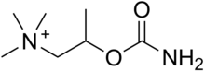
Bethanechol is a parasympathomimetic choline carbamate that selectively stimulates muscarinic receptors without affecting nicotinic receptors. Unlike acetylcholine, bethanechol is not hydrolyzed by cholinesterase and therefore has a long-lasting effect. Bethanechol is marketed under the brand names Duvoid (Roberts), Myotonachol (Glenwood), Urecholine (Merck Frosst), and Urocarb (Hamilton). The name bethanechol is due to its urethane beta-methylcholine structure.
Synthesis of bethanechol:
Bethanechol relieves dry mouth and is sometimes given orally or subcutaneously to treat urinary retention resulting from general anesthesia, diabetic bladder neuropathy, or a side effect of antidepressants; or treat gastrointestinal deficiency of muscle tone. Muscarinic receptors in the bladder and gastrointestinal tract stimulate bladder contraction and urine output, respectively, and increased gastrointestinal motility. Bethanechol should be used to treat these disorders only after mechanical obstruction has been ruled out as a possible cause.
Its potential benefit in the treatment of cerebral palsy has been investigated.

M-anticholinergics (anticholinergic, atropine-like drugs)

Atropine sulfate
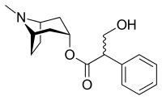
Endo-(±)-alpha-(hydroxymethyl)benzoacetic acid 8-methyl-8-azabicyclo[3.2.1]oct-3-yl ester

Atropine (lat. Atropinum) is an anticholinergic (m-anticholinergic), plant alkaloid. Chemically, it is a racemic mixture of the tropine ester of D- and L-tropic acid. The L-stereoisomer of atropine is hyoscyamine.
Synonym: Atropinum sulfuricum.
An alkaloid found in various plants of the nightshade family: for example, belladonna (Atropa belladonna) [1], henbane (Hyoscyamus niger), various types of Datura (Datura stramonium), etc.
Metabolism of atropine;
-aromatic hydroxylation,
Formation of glucuronato through ester hydrolysis and release of the alcohol function,
-N-demethylation
Blocks m-cholinergic receptors. Causes mydriasis, accommodation paralysis, increased intraocular pressure, tachycardia, xerostomia. Inhibits the secretion of bronchial and gastric, sweat glands. Relaxes the smooth muscles of the bronchi, gastrointestinal tract, bile and urinary systems - antispasmodic effect. Stimulates (large doses) the central nervous system. Application: Peptic ulcer of the stomach and duodenum, pylorospasm, cholelithiasis, cholecystitis, acute pancreatitis, hypersalivation (parkinsonism, heavy metal salt poisoning, dental interventions), irritable bowel syndrome, intestinal colic, biliary colic, renal colic, symptomatic bradycardia (sinus , sinoatrial block, proximal AV block, pulseless ventricular electrical activity, asystole), for preoperative premedication; poisoning with m-holinostimulants and anticholinesterase drugs (reversible and irreversible action), incl. organophosphorus compounds; with X-ray studies of the gastrointestinal tract (if necessary, reduce the tone of the stomach and intestines), bronchial asthma, bronchitis with hyperproduction of mucus, bronchospasm, laryngospasm (prevention).
In ophthalmology. To dilate the pupil and achieve accommodation paralysis (determining the true refraction of the eye, examining the fundus), creating functional rest in inflammatory diseases and eye injuries (iritis, iridocyclitis, choroiditis, keratitis, thromboembolism and spasm of the central retinal artery).

Metacin (Metocinium iodide)
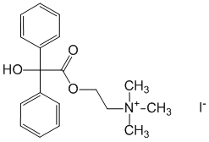
(2-Hydroxyethyl)trimethylammonium iodide benzylate
Competitively blocks m-cholinergic receptors of predominantly peripheral cholinergic structures. Reduces the secretion of bronchial and salivary glands. Relaxes the muscles (relieves spasm) of the esophagus, stomach, intestines. Reduces the amplitude and frequency of uterine contractions.
Application:
Hepatic and renal colic, peptic ulcer of the stomach and duodenum, chronic gastritis; in anesthesiology to reduce the secretion of glands, prevent bronchospasm and circulatory disorders when n.vagus is irritated; in obstetrics for the prevention of miscarriage, premature birth.

Platifillina hydrotartrate

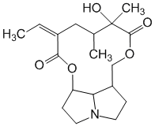
3-Ethylidene-6-hydroxy-5,6-dimethylperhydro-1,8-dioxacyclododeca[2,3,4-gh]pyrrolisine-2,7-dione
The alkaloid platifillin is found in the ragwort rhomboleaf (oakleaf), or broadleaf [Senecio rhombofolius (Willd.)], syn. Senecio platyphyllus D.C. from the Compositae family. Platifillin has an anticholinergic effect. In terms of its effect on peripheral cholinergic systems, it is close to atropine. Less active than atropine, but at appropriate doses is not inferior in action to atropine; better tolerated. Stronger than atropine, it inhibits the cholinergic systems of the autonomic nerve nodes. It has a calming effect on the central nervous system, especially on the vasomotor centers. It also has antispasmodic (papaverine-like) properties. Assign with spasms of smooth muscles of the abdominal organs, peptic ulcer of the stomach and duodenum, bronchial asthma; the drug also reduces spasms of blood vessels (with hypertension, angina pectoris), spasms of cerebral vessels.
In ophthalmic practice, it is used to dilate the pupil. Compared with atropine, the effect on accommodation is little noticeable. The action on the pupil is shorter than the action of atropine and homatropine.

Ipratropium bromide

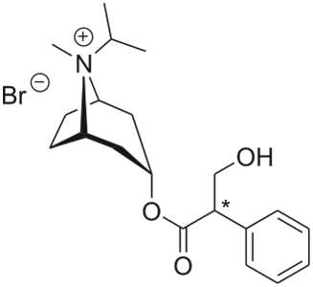
(endo,syn)-(±)-3-(3-Hydroxy-1-oxo-2-phenylpropoxy)-8-methyl-8-(1-methylethyl)-8-azoniabicyclo[3.2.1]-octane bromide
Ipratropium bromide is an anticholinergic drug, a quaternary derivative of atropine (bromide), containing an isopropyl radical at the quaternized nitrogen atom of the tropane heterocycle. It is an anticholinergic drug that acts mainly on bronchial cholinergic receptors. A bronchodilator that blocks m-cholinergic receptors of the smooth muscles of the tracheobronchial tree (mainly at the level of large and medium bronchi) and suppresses reflex bronchoconstriction, reduces the secretion of glands of the nasal mucosa and bronchial glands. Having a structural similarity to the acetylcholine molecule, it is its competitive antagonist. Effectively prevents bronchial constriction resulting from the inhalation of cigarette smoke, cold air, the action of various bronchospasm agents, and also eliminates bronchospasm associated with the influence of n.vagus.
Chronic obstructive pulmonary disease (with or without emphysema), bronchial asthma (mild to moderate severity), especially with concomitant diseases of the cardiovascular system. Bronchospasm during surgical operations, against the background of "cold" diseases. Tests for the reversibility of bronchial obstruction; for the preparation of the respiratory tract before the introduction of antibiotics in aerosols, mucolytic drugs, corticosteroids, cromoglycic acid.
Sinus bradycardia due to the influence of n.vagus, bradyarrhythmia, SA blockade, AV blockade II degree, atrial fibrillation (bradysystolic form).
Scopolamine hydrobromide
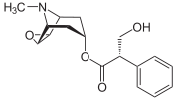
(1R,2R,4S,7S,9S)-9-methyl-3-oxa-9-aza-tricyclo[3.3.1.02.4]non-7-yl-(−)-(S)-3-hydroxy- 2-phenylpropionate
Scopolamine (lat. Scopolaminum; C17H21NO4) is an alkaloid contained together with atropine in plants of the nightshade family (scopolia, belladonna, henbane, dope and some others). In medicine, it is used as an anticholinergic agent.
Used in the form of scopolamine hydrobromide (Scopolamini hydrobromidum).
It also has a central anticholinergic effect. Usually causes a sedative effect: reduces physical activity, may have a hypnotic effect. A characteristic property of scopolamine is the amnesia it causes.
Scopolamine is sometimes used in psychiatric practice as a sedative, in neurological practice for the treatment of parkinsonism, in surgical practice, together with analgesics (morphine, promedol), to prepare for anesthesia, sometimes as an antiemetic and sedative for sea and air sickness, as well as for iritis, iridocyclitis and for diagnostic purposes to dilate the pupil instead of atropine.
At the beginning of the 20th century, scopolamine was proposed as a "truth serum".
Scopolamine in the body is mainly decomposed in the liver and excreted in the urine.

Tropicamide
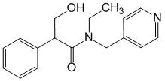

N-Ethyl-alpha-(hydroxymethyl)-N-(4-pyridinylmethyl)benzoacetamide
Blocks m-cholinergic receptors of the sphincter of the iris and ciliary muscle. Expands the pupil, causes paralysis of accommodation.
Application: Diagnosis in ophthalmology (the need for mydriasis and cycloplegia - examination of the fundus, determination of refraction using skiascopy). Inflammatory processes and adhesions of the eye.

Homatropin
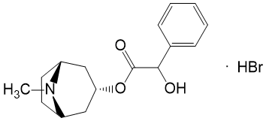

alpha-hydroxybenzoacetic acid endo-±-8-methyl-8-azabicyclo[3.2.1]oct-3-yl ester hydrobromide
Blocks m-cholinergic receptors, prevents m-cholinomimetic action of acetylcholine, inhibits parasympathetic activation. By blocking the responses of the fibers of the circular muscle of the iris and the ciliary muscle to cholinergic stimulation, it causes pupil dilation (mydriasis) and accommodation paralysis (cycloplegia).
Application: Examination of the fundus, determination of the true refraction of the eye (to dilate the pupil and achieve accommodation paralysis); iritis, iridocyclitis, choroiditis, keratitis, embolism and spasm of the central retinal artery, eye injury.

Dicycloverine
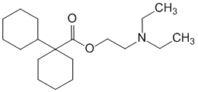
1-Cyclohexylcyclohexanecarboxylic acid beta-(diethylamino)ethyl ester
Eliminates spasm of smooth muscles of the gastrointestinal tract and reduces the pain syndrome caused by it. Animal studies (in vitro studies using isolated guinea pig small intestine) have shown that the effect is mediated by two mechanisms: firstly, a specific anticholinergic effect on acetylcholine receptor sites, similar to that of atropine (antimuscarinic activity), secondly, by a direct effect on smooth muscles, as evidenced by the ability of dicycloverine to block bradykinin- and histamine-induced spasms (atropine does not change the response to these two agonists).
Application: Colic (intestinal, hepatic, renal), algomenorrhea.

Darifenacin
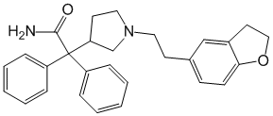
Darifenacin (trade name Enablex in the US and Canada, Emselex in the European Union) is a medicine used to treat urinary incontinence due to an overactive bladder

Pirenzepine (gastrozepine)
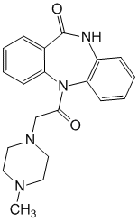
5,11-Dihydro-11-[(4-methyl-1-piperazinyl)acetyl]-6H-pyrido[2,3-b][1,4]benzodiazepin-6-one
Selectively blocks m1-cholinergic receptors at the level of intramural ganglia and turns off the stimulating effect of the vagus nerve on gastric secretion. The cytoprotective effect is associated with the improvement of microcirculation in the gastric mucosa and the suppression of intragastric proteolysis.
Application:
Peptic ulcer of the stomach and duodenum (treatment and prevention); chronic hyperacid reflux esophagitis; erosive and ulcerative lesions of the gastrointestinal tract, incl. caused by antirheumatic and anti-inflammatory drugs; stress ulcers of the gastrointestinal tract; Zollinger-Ellison syndrome; bleeding from erosions and ulcerations in the upper gastrointestinal tract.
Pryfinium bromide
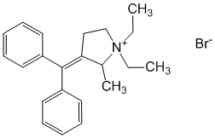
3-(Diphenylmethylene)-1,1-diethyl-2-methylpyrrolidinium bromide
M-anticholinergic from the group of quaternary ammonium compounds. Affects m-cholinergic receptors of various localization, incl. Gastrointestinal, biliary, urinary tract: effectively eliminates and prevents spasms of smooth muscles, lowers the tone of smooth muscles, weakens peristalsis. Reduces the secretory activity of the digestive glands.
Application:
Pain syndrome associated with spasms of smooth muscles of the biliary tract, urinary tract, gastrointestinal tract; premedication before instrumental and X-ray examination of the gastrointestinal tract; vomiting, flatulence, spasms of smooth muscles of the gastrointestinal tract in newborns and young children.
Means affecting n-cholinergic receptors
N-cholinomimetics (nicotinomimetics)

Cytisine (Cititon)
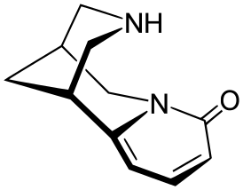

Cytisine (Cytisinum) (aka cytisinicline) is an alkaloid contained in the seeds of the Russian broom plant (Cytisus ruthenicus FISCH. ex WOL.) and Thermopsis lanceolate (Thermopsis lanceolata R.BR.), both from the legume family (Fabaceae, or Leguminosae).
Refers to substances of "ganglionic" action and in connection with the stimulating effect on respiration is considered as a respiratory analeptic. For this purpose, it is produced in the form of a ready-made 0.15% aqueous solution called Cytiton (Cytitonum).
Cytisine is also used in the form of tablets (drugs "Nikurilla", "Tabex", "Recigar® A").
Cytisine has a stimulating effect on the ganglia of the autonomic nervous system and related formations: the chromaffin tissue of the adrenal glands and carotid glomeruli.

Lobeline hydrochloride
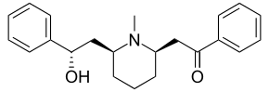

Lobelin (Lobelinum) is an alkaloid contained in the plant Lobelia inflata L., fam. bellflowers (Campanulaceae). In medical practice, it was used as an analeptic, as a respiratory stimulant, as an aid in smoking cessation. Tablets containing lobelin are produced for this purpose under the name "Lobesil" (Tabulttae "Lobesilum"). Each such tablet contains 0.002 g (2 mg) of lobelin hydrochloride.
Nicotine
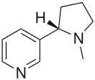
Nicotine (from lat. Nicotiána - tobacco) is a toxic alkaloid of the pyridine series contained in plants of the nightshade family (Solanaceae), mainly in leaves and stems of tobacco (dry concentration from 0.3 to 5% by weight), shag (2-14 %), in smaller quantities - in tomatoes, potatoes, eggplants, green peppers.
The name "nicotine" comes from the Latin name for tobacco Nicotiana tabacum, which, in turn, was coined in honor of Jean Nicot, the French ambassador to the Portuguese court, who in 1560 sent some tobacco to Queen Catherine de Medici, recommending it as a remedy for migraines.
Nicotine acts on nicotinic acetylcholine receptors: the protonated nitrogen atom of the pyrrolidine ring in nicotine mimics the quaternary nitrogen atom in acetylcholine, and the pyridine nitrogen atom has the character of a Lewis base, like the oxygen of the keto group of acetylcholine.
Historically, nicotine has often been used for medicinal purposes. The use of nicotine for the treatment of various diseases is also being developed. The most common direction is the delivery of nicotine into the body by alternative routes for the treatment of nicotine addiction. Other applications of nicotine are also being explored, such as a pain reliever, treatment for attention deficit disorder, Alzheimer's disease, Parkinson's disease, colitis, herpes, tuberculosis and schizophrenia. In 2020, French scientists attempted to prove the preventive and therapeutic role of nicotine in relation to COVID-19.
Anabasine hydrochloride
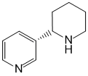
3-(2-Piperidinyl)pyridine
Excites n-cholinergic receptors, reduces the craving for smoking. In large doses, it has an analeptic effect, incl. excites the respiratory center of the medulla oblongata.
Uses: Nicotine addiction (relief of symptoms when quitting smoking).

Blockers of n-cholinergic receptors or related ion channels
Ganglion blocking agents
Benzohexonium

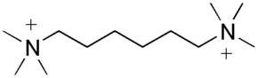
1,6-bis-(N-trimethylammonium)-hexane dibenzenesulfonate
Hexamethonium benzosulfonate is a drug, a ganglionic blocker.
Other salts of 1,6-bis-(N-trimethylammonium)-hexane may be used instead of the dibenzenesulfonate. Diiodide was produced under the name "Hexonium".
Ganglioblokator, blocking n-cholinergic receptors of autonomic ganglia, inhibits the transmission of nerve excitation from preganglionic to postganglionic fibers. It has a depressing effect on the carotid glomeruli and chromaffin tissue of the adrenal glands, which helps to weaken the reflex pressor effects.
It causes a decrease in blood pressure, motility of the gastrointestinal tract, bladder tone, secretion of exocrine glands, paresis of accommodation, dilates the bronchi, increases the heart rate.
Indications:
Obliterating diseases of peripheral arteries (endarteritis, “intermittent” claudication), arterial hypertension (including for the relief of hypertensive crises), the need for controlled hypotension, peptic ulcer of the stomach and 12 duodenal ulcer, chronic gastritis, bronchial asthma (some forms), diencephalic syndrome.
Azamethonium bromide (Pentamine)
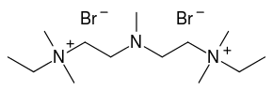
3-Methyl-1,5-bis-(N, N-dimethyl-N-ethyl-ammonium)-3-azapentane dibromide.
Ganglioblocking agent, blocks n-cholinergic receptors of autonomic ganglia (sympathetic and parasympathetic). It has a depressing effect on carotid glomeruli and chromaffin tissue of the adrenal glands. In high doses, it can block n-cholinergic receptors in skeletal muscles and the central nervous system. It has a hypotensive, arterio- and venodilating effect. It reduces the excretion of catecholamines by the adrenal glands and weakens reflex pressor reactions, which causes tachycardia, accommodation paresis, mydriasis, bronchial dilation, decreased motility of the gastrointestinal tract and secretion of glands, and bladder tone. Indications: Hypertensive crisis; spasm of peripheral vessels, intestines and biliary tract, obliterating lesions of peripheral vessels (endarteritis, atherosclerosis, etc.), pain syndrome in gastric and duodenal ulcers, intestinal colic, biliary colic, renal colic, bronchial asthma (for the relief of acute attacks) , eclampsia, causalgia, pulmonary edema, cerebral edema. In anesthesiology - for controlled arterial hypotension. In urological practice - with cystoscopy in men (to facilitate the passage of the cystoscope through the urethra).
Trepyrium bromide (hygronium)
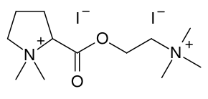
Refers to bisquaternary ammonium compounds, structurally similar to dimecoline.
It has a short-term ganglioblocking effect, and therefore it is convenient for use in anesthetic practice for controlled hypotension.

Pempidine (Pyrilene)
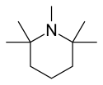
1,2,2,6,6-Pentamethyl-piperidine p-toluenesulfonate.
Pyrilene is a tertiary amine. Compared with quaternary ammonium compounds, pyrilene is better absorbed when taken orally and has a rapid ganglioblocking and hypotensive effect with this method of application. Pyrilene penetrates the blood-brain barrier and has a blocking effect on the central n-cholinergic receptors.
Pyrilene is used for spasms of peripheral vessels, peptic ulcer of the stomach and duodenum, toxicosis of pregnant women. In hypertension, pyrilene can be used in combination with other antihypertensive drugs (reserpine, dichlothiazide, etc.).
Trimetafan (Arfonad)
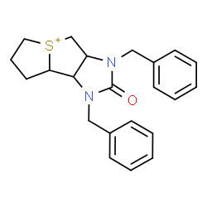
Arfonad lowers blood pressure through ganglionic blockade with peripheral vasodilation (expansion of the lumen of the vessels). It has a fast, pronounced, but very short-term effect.
Artificial hypotension (artificially controlled decrease in blood pressure) in surgery, acute pulmonary edema in hypertensive patients with left ventricular failure, hypertensive crises (rapid and sharp rise in blood pressure).
Trepyria iodide

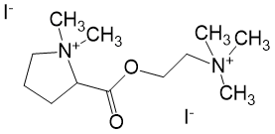

2-Carboxy-1,1-dimethylpyrrolidinium iodide ester
It blocks n-cholinergic receptors of the autonomic ganglia (inhibits the transfer of excitation from preganglionic to postganglionic fibers of the autonomic nerves) of the adrenal medulla and the carotid sinus zone. Reduces the flow of vasoconstrictor impulses to the vessels and the release of adrenaline by the adrenal glands, weakens reflex pressor reactions, lowers blood pressure.

Pachycarpine
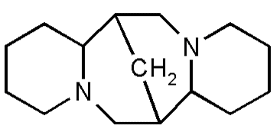
[7R-(7alpha,7a alpha,14alpha,14a beta)]-dodecahydro-7,14-methano-2H,6H-dipyrido[1,2-a:1',2'-e][1,5]diazocin
Pahikarpin (lat. Pachycarpinum) - an alkaloid contained in the plant Sophora thick-fruited (Sophora pachycarpa C. A. M.), fam. legumes (Leguminosae); also found in Thermopsis lanceolata R. BR. and other plants. It is used in medicine as a ganglion blocker.
It blocks n-cholinergic receptors of autonomic (sympathetic and parasympathetic) ganglia and disrupts the transmission of nerve impulses from preganglionic to postganglionic fibers, changing the functions of organs receiving autonomic innervation. Reduces the sensitivity to acetylcholine of n-cholinergic receptors of the chromaffin tissue of the adrenal medulla and carotid glomeruli.
Reduces the flow of sympathetic vasoconstrictor impulses to blood vessels, lowers the tone of arterioles and veins, reduces peripheral vascular resistance and venous return. Inhibition of impulse conduction along cholinergic nerve fibers leads to a weakening of the motility of the digestive tract, inhibition of gland secretion, incl. the appearance of dry mouth, increased heart rate, lowering the tone of the bladder. It increases the tone, enhances the rhythmic contractions of the muscles of the uterus, enhances labor activity with its weakness or early discharge of water.

Curare-like drugs (muscle relaxants of peripheral action)
Tubocurarine chloride
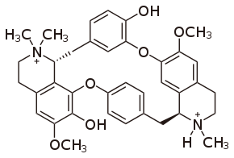
Tubocurarine chloride (d-Tubocurarine chloride) is an alkaloid of plant origin that has a muscle relaxant physiological effect and, due to the presence of such biological activity, is used in medicine as a muscle relaxant in the form of a drug tubocurarine chloride (Tubocurarini chloridum). It is one of the active ingredients of curare poison and is chemically a derivative of bis-benzylisoquinoline (included in a group of about 400 compounds of similar structure found in various plant species). It is used as a muscle relaxant in acute spastic conditions (convulsions) of skeletal muscles (for example, in case of strychnine poisoning, tetanus, some mental illnesses) and as an aid in surgical anesthesia in traumatology and thoracic and abdominal surgery (significantly improves the course of both anesthesia itself and post-anesthetic period).
Pancuronium bromide
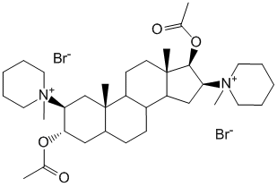

1,1'-[(2beta,3alpha,5alpha,16beta, 17beta)-3,17-bis(Acetyloxy)androstan-2,16-diyl]bis[1-methylpiperidinium] dibromide
Competes with acetylcholine for n-cholinergic endplate receptors, causing blockade of neuromuscular transmission. Muscle paralysis develops gradually in the following sequence: levator eyelid muscles, chewing muscles, limb muscles, abdominal muscles, muscles of the glottis, intercostal muscles and diaphragm. Does not cause muscle twitches.
Application: The need for muscle relaxation during various types of surgical interventions (including caesarean section) using mechanical ventilation.
Pipecuronium bromide
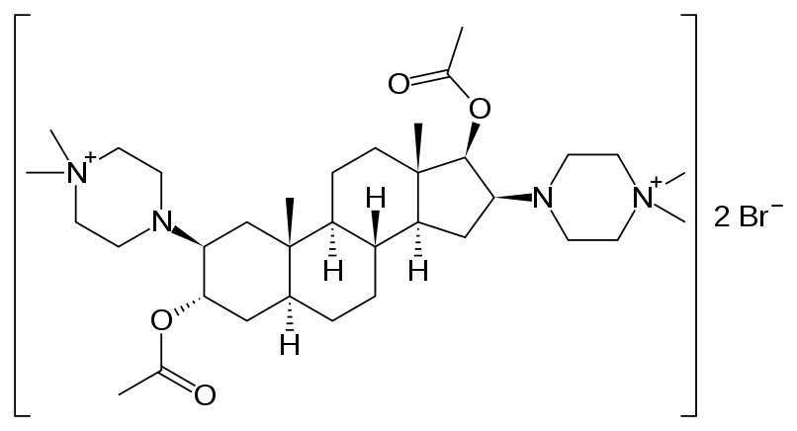
2beta,16beta-bis-(4,4-Dimethyl-1-piperazinium)-3alpha,17beta-diazepoxy-5alpha-androstane dibromide
Due to the competitive connection with n-cholinergic receptors located on the end plate of the neuromuscular synapse of skeletal muscles, it blocks signal transmission from nerve endings to muscle fibers. Its antidotes are acetylcholinesterase inhibitors (eg neostigmine, pyridostigmine, edrophonium). Unlike depolarizing muscle relaxants (eg succinylcholine), it does not cause muscle fasciculations. Does not have a hormonal effect. Application: Endotracheal intubation and relaxation of skeletal muscles under general anesthesia during various surgical procedures requiring more than 20-30 minutes of muscle relaxation under mechanical ventilation.

Vecuronium bromide
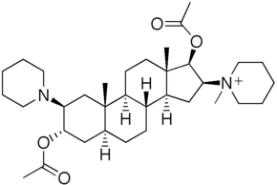
1-[(2beta,3alpha,5alpha,16beta,17beta)-3,17-bis-(Acetyloxy)-2-(1-piperidinyl)androstan-16-yl]-1-methylpiperidinium bromide
Vecuronium is a competitive antagonist of acetylcholine for skeletal muscle n-cholinergic receptors. It practically does not have a ganglioblocking and m-anticholinergic action, less often, in comparison with other muscle relaxants, it promotes the release of histamine.
Indications: Relaxation of skeletal muscles (during surgical operations under general anesthesia); convulsive syndrome (including against the background of an overdose of other drugs or as a result of exposure to electric current).

